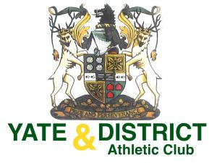

Yate and District Athletic Club Social Media Policy

Social media (including personal and professional websites, blogs, chat rooms and bulletin boards; social networks, such as Facebook, LinkedIn, Twitter and Instagram; video-sharing sites such as YouTube) are a common means of communication and self-expression.
It’s essential that volunteers, staff, committee members and athletes make informed decisions about how they use the internet, mobile phone and email communications to protect our club and our people.

Everyone involved in YAC has the responsibility to safeguard both on and off the track/field, including communications.

It is the responsibility of all members to:-
- Refrain from publishing comments about other clubs, athletes, coaches and officials and any controversial or potentially inflammatory subjects.
- To ensure that all posts are age appropriate considering YAC membership age range.
- Avoid hostile or harassing communications in any posts or other online communications. Harassment is any offensive conduct based on a person`s race, sex, gender identity, national origin, colour, disability, age sexual orientation, veteran status, marital status, religion or any other status protected by law.
- Clubs should identify all copyrighted or borrowed material with citations and links. When publishing direct paraphrased quotes, thoughts, ideas, photos or videos, give credit to the original publisher or author.
- The club will be responsible for reviewing responses to online posts and resolving any concerns before they are posted.
- If a blogger or any other online participant posts an inaccurate, accessory or negative comment about your club or anyone associated with the club, do not reply but seek advice from England Athletics, UKA or Sport England.

